Violet May Standiford
August 19, 1916 – December 10, 1916

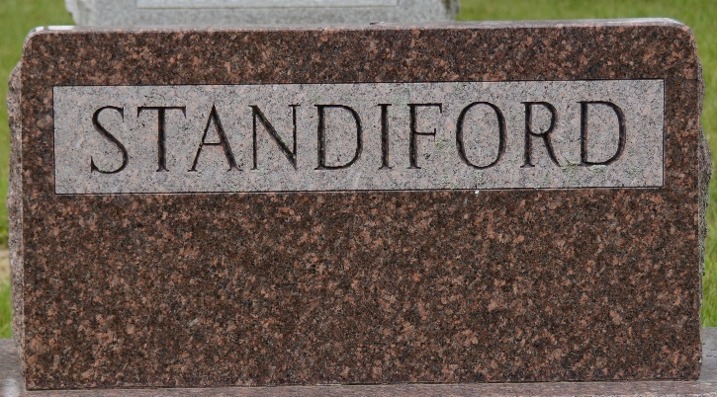
Photo by Deb Curry

STANDIFORD BABE DEAD
Infant Daughter of Merle Standiford Succumbs
Violet May, infant daughter of Mr. and Mrs. Merle Standiford, of S. Twelfth Street, born August 19, died Sunday afternoon at 12:30 o'clock, after an illness of kidney trouble.
The child was the only one in the family. The mother was formerly Miss Nellie Barkley, of Ohio.
The funeral will be held Tuesday morning at ten o'clock from the home, the Rev. F. H. Harman, of the United Brethren Church officiating. Burial will take place in the city cemetery.

Decatur Daily Democrat, Adams County, Indiana
Monday, December 11, 1916
**
Indiana, U.S., Death Certificates, 1899-2017
Name Violet May Standiford
Gender Female
Race White
Marital Status Single
Age 3 months, 21 days
Birth Date 19 Aug 1916
Birth Place Decatur, Indiana
Death Date 10 Dec 1916
Death Place Decatur, Adams, Indiana, USA
Death Registration Date 1916
Father Merl Standiford
Mother Nellie Barkley
Informant Merl Standiford; Decatur, Indiana
Burial December 12, 1916; Decatur Cemetery

