Paris Lee Standiford
January 26, 1903 – November 1, 1958

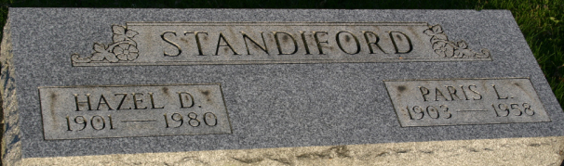
Photo by Margie Pearce

Paris L. Standiford, 55, died at 4 a.m. Saturday in his home at 4323 Paulding Rd. Death was unexpected. Mr. Standiford who resided here 36 years, was a machinist for the U. S. Rubber Co. plant here and was a member of the South Wayne Evangelical United Brethren Church.
Surviving are the widow, Hazel; two sons, Francis, Fort Wayne, and Ivan, at home; one daughter, Mrs. Harold Cox, Columbia City; two brothers, Merle, Wakeman, Ohio, and Harold, Fort Wayne; two sisters, Mrs. Olive Schifferly, Constantine, Mich., and Mrs. Iva Rademacher, Fort Wayne, and six grandchildren.
The body was taken to the Zwick Funeral Home, Decatur, where friends may call after 2 p.m. today and until 11 a.m. Tuesday, when the body will be taken to the South Wayne church for services at 1:30 p.m. The Rev. Frank Engle will officiate, and interment will be in Decatur Cemetery.

Journal-Gazette, Allen County, Indiana
Sunday, November 2, 1958

**
Indiana, U.S., Death Certificates, 1899-2017

Name Paris Lee Standiford
Gender Male
Race White
Marital Status Married
Age 55
Birth Date 26 Jan 1903
Birth Place Van County, Ohio
Death Date 1 Nov 1958
Death Place Fort Wayne, Allen, Indiana, USA
Death Registration Date 1958
Father Charles Standiford
Mother Jennevva Merica
Informant Mrs. Hazel Standiford; wife; Fort Wayne, Indiana
Burial November 4, 1958; Decatur Cemetery; Decatur, Indiana

