Oren Lester Standiford
March 4, 1893 – December 8, 1918

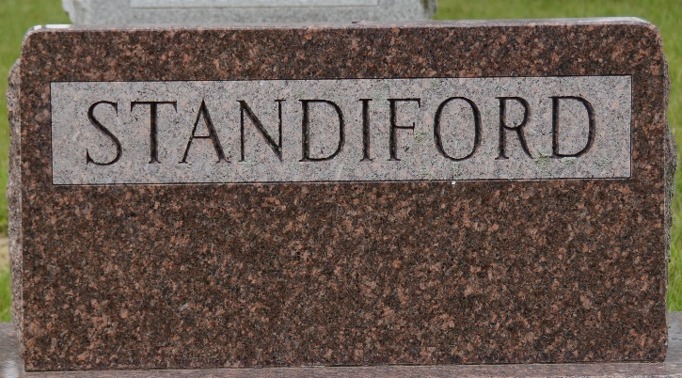
Photo by Deb Curry

VICTIM OF FLU
The body of Oren or "Dick" Standiford, former Decatur barber, employed by John Rabbit, will be brought here tomorrow at 11:30 over the Erie for burial in the Decatur cemetery, where the body will be taken from the train. The death of the young man, who was twenty-six years of age last March, resulted from influenza, and he was ill only since Thursday.
He is survived by the wife, who was Miss Flossie Miller, a sister of Otis E. Miller, of Line street, the local Prudential insurance agent; and also by a two year old son, Richard.
The deceased was a son of Charles Standiford and was born in Harrison Township, Van Wert County, O., about six miles east of this city. The family moved here five or six years ago last September.
Surviving also are the father, at Lima, and the following brothers and sisters: Clyde, Merle, Paris and Harold Standiford; Iva Standiford, Mrs. Herb Steele, of Lima; and Mrs. Vernon Shifferly of North Eleventh Street.

Decatur Daily Democrat, Adams County, Indiana
December 9, 1918
**
FORMER DECATUR BARBER DEAD
(Spec. to the news) DECATUR, Ind., Dec 10 – The body of Oren or "Dick" Standiford, former Decatur barber, was brought here today from Lima, Ohio, where death resulted from influenza and complications. Burial will be in Decatur Cemetery.
The deceased was 26 years of age and leaves a wife, who was Flossie Miller, and a 2-year-old son.
The deceased was the son of Charles Standiford and was born 6 miles east of this city where they lived until moving to Decatur about 6 years ago. During the residence here, the deceased was employed at the John Rabbit barber shop.
He leaves, besides the wife and son, 4 brothers and 3 sisters. They are: Clyde, Merle, Paris, Harold, Iva, Mrs. Herb Steele, of Lima; Mrs. Vernon Shifferly, Decatur.

News & Sentinel, Allen County, Indiana
Tuesday, December 10, 1918
**
Death • Ohio, Deaths, 1908-1953
Name Oren Lester Standiford
Age 25
Birth Date 04 Mar 1893; Birthplace Ohio
Burial Date 10 Dec 1918; Burial Place Decatur, Indiana
Marital Status Married
Occupation Machinist
Race w
Father's Name Charley Allen Standiford; Father's Birthplace Ohio
Mother's Name Kennerga Merica; Mother's Birthplace Ohio
Event Type Death
Event Date 08 Dec 1918
Event Place Lima, Allen, Ohio
Event Place (Original) Lima, Allen, Ohio
Informant Mrs. Oren L. Standiford
Source Details fn 85010

