Hazel D. (Harman) Standiford-Johnson
August 15, 1901 – October 15, 1980

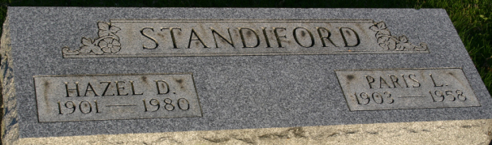
Photo by Margie Pearce

Hazel Johnson, 79, Route 9, Columbia City, and a former resident of Decatur, died at 1:13 p.m. Wednesday at the Alfran Nursing Home, where she had resided for six months after suffering a broken hip.
She was a member of the South Wayne United Methodist Church, Fort Wayne,
Born in Van Wert County, Ohio, on 15 August 1901, she was the daughter of Alfred and Ellen Hurless-Harmon, and was first married to Paris Lee Standiford, who died 4 November 1958. She married Zeal Johnston on 29 June 1963, and he survives.
Also surviving are three children; Mrs. Harold (Iris) Cox, Columbia City; Ivan Standiford, Fort Wayne, Francis Standiford, Fort Wayne; 16 grandchildren; and seven great-grandchildren. One sister is deceased.
Funeral services will be held at 1:30 p.m. Saturday at Zwick Funeral Home with Rev. M. C. McCracken officiating. Burial will be in the Decatur Cemetery. Friends may call at the funeral home after 7 p.m. today.
Preferred memorials are to the Heart Association.

Decatur Public Library, Adams County, Indiana
Obit Book #5
**
Indiana, U.S., Death Certificates, 1899-2017
Name Della Hazel Johnson
[Della Hazel Harman]
Gender Female
Race White
Marital Status Married
Age 79
Birth Date 15 Aug 1901
Birth Place Ohio
Death Date 15 Oct 1980
Death Place Columbia City, Whitley, Indiana, USA
Death Registration Date 1980
Father Alfred Harman
Mother Ellen Hurless
Spouse Zearl Johnson
Informant Mrs. Harold Cox; daughter; Columbia City, Indiana
Burial October 18, 1980; Decatur Cemetery; Decatur, Indiana

