Jennevva May (Merica) Standiford
February 5, 1868 – July 25, 1914

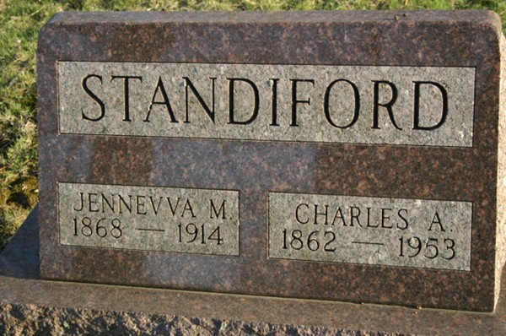
Photo by Margie Pearce

DIES OF CANCER
Mrs. Charles A. Standiford is Called by Death Saturday Evening After Long Illness
Funeral Services Were Held This Afternoon from the Baptist Church.
Death claimed Mrs. Charles A. Standiford of this city Saturday evening at six-ten o'clock after a long illness from cancer of the liver. Mrs. Standiford had been in poor health for a number of years and during this time her suffering was very great. Cancer of the liver finally set in which gradually resulted in her death.
Mrs. Charles Standiford was a daughter of Mr. and Mrs. Steven Merica of Van Wert and was born in that city on the 5th day of February, 1868. She lived in and around Van Wert up until a few years ago when her husband and children moved to this city and Mr. Standiford secured employment in the Schlickman feed yard.
The deceased was a most lovable lady and was only 46 years, 5 months and 20 days old. Her presence within the family circle will be greatly missed and the happy circle will be broken up without her.
She is survived by eight children, Mrs. Olive Schifferly, Clyde, Oren, Cario, Iva, Paris and Harold Standiford of this city and Merl of Van Buren.
The funeral services were held this afternoon at one thirty o'clock from the Baptist Church, the Rev. Hamilton of Wren officiating. Burial was made in the Maplewood Cemetery.

Decatur Daily Democrat, Adams County, Indiana
Monday, July 27, 1914
**
Indiana, U.S., Death Certificates, 1899-2017
Name Jenevva May Standiford
[Jenevva May Merica]
Gender Female
Race White
Marital Status Married
Age 46
Birth Date 5 Feb 1868
Birth Place Van Wert County, Ohio
Death Date 25 Jul 1914
Death Place Decatur, Adams, Indiana, USA
Death Registration Date 1910-1919
Father Steven D Merica
Mother Mary Roop
Spouse Charles A Standiford
Informant Chas. A. Standiford; Decatur, Indiana
Burial July 27, 1914; Decatur Cemetery

