Imogene M. Standiford
October 14, 1920 – October 17, 1923

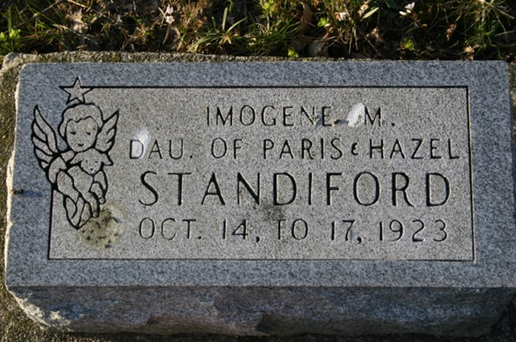
Photo by Margie Pearce

Imogene Standiford, aged two days, died at the home of her parents, Mr. and Mrs. Paris Standiford, 1508 Fisher Street, at 10 o'clock this morning, of anemia.
Funeral services will be held at the home at 1 o'clock Thursday afternoon. Burial in Decatur.

News-Sentinel, Allen County, Indiana
Wednesday, October 17, 1923
**
Imogene Standiford
in the Indiana, U.S., Death Certificates, 1899-2017
Name Imogene Standiford
Gender Female
Race White
Age 3 days
Birth Date 14 Oct 1920
Birth Place Indiana
Death Date 17 Oct 1923; premature
Death Place Fort Wayne, Allen, Indiana, USA
Death Registration Date 1923
Father Paris Standiford
Mother Hazel Harman
Informant Paris Standiford
Burial October 18, 1923; Decatur, Indiana

