Charles A. Standiford
December 12, 1862 – February 21, 1953

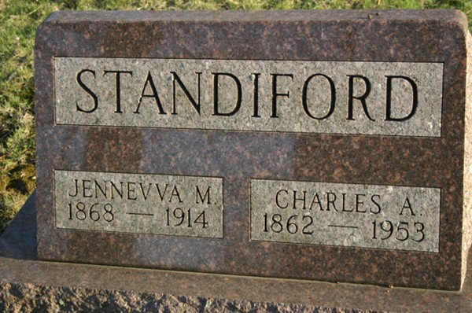
Photo by Margie Pearce

Charles A. Standiford
The father of a Fort Wayne resident, Charles A. Standiford, 90, Rockford, O., died last night in the home of a son, Paris, Paulding Road. He had been ill two years. He was a retired farmer.
Surviving are three sons, Merl, Rockford, O., Harold, Fort Wayne, and Paris; two daughters, Mrs. Vern Shifferly, Sturgis, Mich., and Mrs. Iva Rademacker, Fort Wayne; one brother, Frank, Van Wert, O.; one sister, Mrs. Fannie Jackson, Decatur; 18 grandchildren and 17 great-grandchildren.
The body was removed to the Zwick Funeral Home in Decatur where friends may call after 7 p.m. today.

Journal-Gazette, Allen County, Indiana
Sunday, February 22, 1953
**
Decatur. Feb. 22 – Charles A. Standiford, 90, of Rockford, O., a retired farmer died at 8:25 p.m. yesterday at the home of son, Paris Standiford on Paulding Road. Also surviving are two other sons, Harold Standiford, Fort Wayne and Merl Standiford, Rockford; two daughters, Mrs. Vern Shifferly, Sturgis, Mich. and Mrs. Iva Rademacker, Fort Wayne, 18 grandchildren; 17 great-grandchildren; a brother, Frank Standiford, Fort Wayne and a sister Mrs. Fannie Jackson, Decatur.
The body is here at the Zwick Funeral Home where friends may call. Services will be conducted at 2 p.m. Tuesday at the funeral home, the Rev. Garrison Roebuck officiating. Burial will be in the Decatur Cemetery.

Journal-Gazette, Allen County, Indiana
Monday, February 23, 1953
**
Standiford Rites Tuesday Afternoon
Charles Standiford Is Taken By Death
Funeral services will be held Tuesday for Charles A. Standiford, 90, of Rockford, O., retired farmer and former resident of Decatur, who died Saturday evening at the home of a son, Paris, of near Fort Wayne. He had been ill two years.
He was born in Allen County, O., Dec. 12, 1862, a son of George W. and Adelin Shockey-Standiford, and was married April 12, 1888, to Jennevva Merica, who died July 25, 1914. Mr. Standiford lived in Decatur from 1912 to 1918.
Surviving are three sons, Paris, Merl of Rockford, and Harold of Fort Wayne; two daughters, Mrs. Vern Schifferly of Sturgis, Mich., and Mrs. Iva Rademacker of Rot Wayne; 18 grandchildren; 17 great-grandchildren; one brother, Frank Standiford of Van Wert, O., and one sister, Mrs. Fannie Jackson of Decatur. Two sons, one daughter, two brothers and one sister are deceased.
Services will be conducted at 2 p.m. Tuesday at the Zwick Funeral Home, with the Rev. Garrison Roebuck officiating. Burial will be in the Decatur Cemetery. Friends may call at the funeral home until time of the services.
Unknown source
**
Charles A. Standiford, 90, Rockford, O., died Saturday night at the home of a son, Paris, Paulding Road, after a 2-year illness.
Survivors include two other sons, Merl, Rockford, O., and Harold, Fort Wayne; two daughters, Mrs. Vern Schifferly, Sturgis, Mich., and Mrs. Iva Rademacker, Fort Wayne; a brother, Frank, Van Wert, O.; a sister, Mrs. Fannie Jackson, Decatur; 18 grandchildren, and 17 great-grandchildren.
Friends may call at the Zwick Funeral Home, Decatur.
Unknown source

