Milo Chester Stalter
June 23, 1925 – March 14, 1944

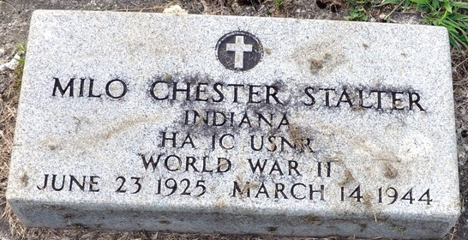
Photo by Deb Curry

DECATUR SAILOR IS KILLED IN SERVICE
Milo Stalter Dies in Nation's Service

Milo Chester Stalter, hospital apprentice first class of the U. S. Navy Reserve, 18-year-old son of Mr. and Mrs. Dorus Stalter, 310 N. First Street was killed March 14, "as a result of a fall from a truck while in the performance of duty and in the service of his country." according to a message received from the navy by the parents today.
The message, which was signed by Vice-Admiral Randall Jacobs, chief of naval personnel, did not state where the fatal accident occurred. The parents are of the opinion that it happened somewhere in the Pacific area, since the son's address was in care of the postmaster at San Francisco. He was attached to a naval air station dispensary. Interment of the body was made in allied territory outside of the continental United States.
The sad tidings were the second in two weeks to be received by Decatur parents of the death of their sons in the service of their country and increased the list of honored dead of men from this county who are serving in World War II. The death of Sgt. Willis Taylor, killed in action in Italy, was reported recently.
The notification read:
"The navy department deeply regrets to inform you of the death of your son, Milo Chester, hospital apprentice first class, USNR, March 14, as a result of injuries received in a fall from a truck while in the performance of duty and in the service of his country. Remains were interred in Allied territory outside of continental limits of United States, pending cessation of hostilities."
The young hero enlisted in the navy on his 17th birthday anniversary June 23 1942. He was a junior in Decatur High School. He served his boot training and specialist training at Great Lakes naval training station.
Two of his brothers are serving their country in the army. They are Lt. Robert A. Stalter, stationed in North Africa, and Pvt. Dale W. Stalter, stationed in England. One brother, Dorus A. Jr. is at home.
Besides the parents and three brothers, he is survived by his grandparents, Mr. and Mrs. Nathan Roop and Mrs. Burlan Gause of this city.
Decatur Daily Democrat, Adams County, Indiana
Friday, March 17, 1944

**
U.S., Headstone Applications for Military Veterans, 1861-1985
Name Milo C Stalter
Birth Date 23 Jun 1925
Service Number 6265175
Service Branch U. S. Navy, U. S N R
Enlistment Date 23 Jun 1942
Death Date 14 Mar 1944
Cemetery Decatur Cemetery
Cemetery Location Decatur, Indiana, USA

