Mart Stalter
November 3, 1875 - 1953

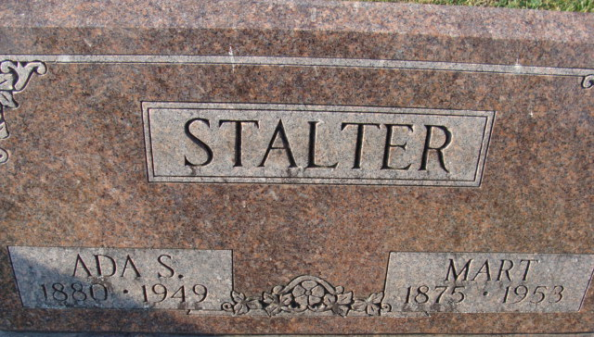
Photo by Alicia Kneuss

Martin (Mart) Stalter from tree Christopher Wolfe Family Tree
Birth 3 Nov 1875 Adams, Indiana, USA
Marriage 28 Aug 1902 Hoagland, Allen, Indiana, USA
Residence 1 Apr 1940 Fort Wayne, Allen, Indiana, USA
Death 1953
Father (68F) Rev Abraham Stalter (1840-1910)
Mother Barbara (Barb) Beery (1844-1906)
Spouse Ada S Fisher (Born 1881)

