Dorus A. Stalter
February 27, 1895 – December 11, 1971

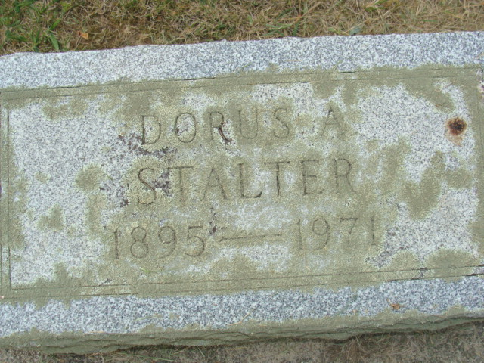
Photo by Alicia Kneuss

DORUS STALTER, 76, DIES AT HOSPITAL
Dorus A. Stalter, 76, of 148 1/2 South Second Street, native and lifelong resident of Adams County, died at 6:34 a.m. today at the Adams County Memorial Hospital following a long illness.
Born at Peterson Feb. 27, 1895, he was a son of Christopher and Emma Bowers-Stalter, and was married to Catherine Roop Nov. 28, 1914.
Mr. Stalter, a retired employee of the Wayne Novelty Corp., was a member of the Loyal Order of Moose.
Surviving are his wife; three sons, Dorus A. Stalter, Jr., of Deming, NM; Dale W. Stalter of Garrett, and Robert A. Stalter of Tacoma, WA; seven grandchildren and 11 great-grandchildren. A son, Milo, and one sister and two brothers are deceased.
Funeral rites will be held at 4:30 p.m. Monday at the Winteregg-Linn Funeral Home, with burial in the Decatur cemetery. Friends may call at the funeral home after 2 p.m. Sunday until time of the services.

Decatur Daily Democrat, Decatur, Adams County, Indiana
Saturday, December 11, 1971

