Dorothy M. (Kiefer) Stalter
September 10, 1923 – August 25, 2009

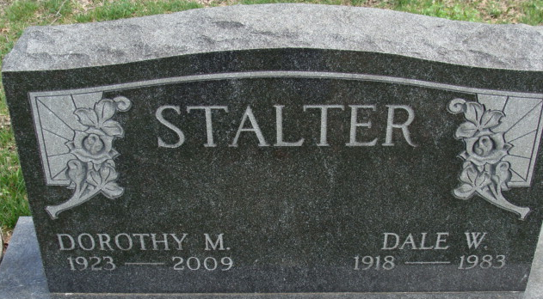
Photo by Alicia Kneuss

Dorothy M. Stalter, 85, of Garrett, died on Tuesday, August 25, at Miller's Merry Manor in Garrett. She was born in Decatur on September 10, 1923, to Emil and Louise Savio Kiefer, who have passed away.
She worked at the General Electric Co. plant in Fort Wayne and was a greeter at the Walmart store in Auburn for many years. She also was a member of the Moose Auxiliary and the Disabled American Veterans.
She married Dale W. Stalter on October 18, 1941, in Fort Wayne; he died in August of 1983.
She is survived by a son and daughter-in-law, Larry D. and Pat Stalter of Garrett; three grandsons, Eric Stalter, Ken Stalter (and wife Nicole), and Brian Stalter (and wife Tracey), all of Garrett; three great-grandchildren, Sammantha, Nicolas, and Klarissa Stalter; two stepgreat-grandchildren, Chelsi Maumer and Nick Gaumer; and one sister-in-law, Liz Kiefer of Auburn.
She was preceded in death by her parents; her husband; one brother, Emil "Bud" Kiefer; and three sisters, Marie Shirley, Helen Beberstine, and Ruth Kenworthy.
Private family funeral services will take place, with burial in Decatur Cemetery.
Memorials may be directed to the DeKalb County Humane Shelter.
Feller and Clark Funeral Home in Auburn assisted the family with the arrangements.

Decatur Daily Democrat, Adams County, Indiana
Wednesday, August 26, 2009

