Dale W. Stalter
December 4, 1918 – August 25, 1983

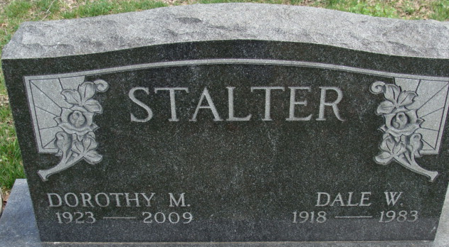
Photo by Alicia Kneuss

Dale W. Stalter, 64, route 1, Hudson, a former resident of Decatur, died at 3:50 Thursday at his home, following a three-year illness.
He was a member of the Zion Lutheran Church and was a retired Fort Wayne General Electric Co. employee. He was a former member of the American Legion.
Born in Decatur on Dec 4, 1918, he was the son of Dorus and Catherine Roop-Stalter, and was married in Decatur on Oct. 18, 1941, to Dorothy Kiefer, who survives. Also surviving are one son, Larry, Garrett; two brothers, Dorus, Tucson, Ariz., and Robert, Reno, Nev.; and three grandchildren. One brother, Milo, preceded him in death.
Services will be held on Monday at 10:30 am at the McKee-Miles Funeral Home, Garrett, with Rev. Lorin Harrison officiating. Graveside services will be held at 12:30 pm Monday at the Decatur Cemetery, with military services by the Legion. Friends may call at the funeral home from 7-9 pm Saturday and 7-9 pm Sunday.

Unknown source

**
Indiana, U.S., Death Certificates, 1899-2017
Name Dale W. Stalter
Gender Male
Race White
Marital Status Married
Age 64
Birth Date 4 Dec 1918
Birth Place Indiana
Death Date 25 Aug 1983
Death Place Hudson, Steuben, Indiana, USA
Death Registration Date 1983
Father Dorus Stalter
Mother Catherine Roop
Spouse Dorothy Kiefer
Informant Dorothy Stalter; Hudson, Indiana
Burial August 29, 1983; Decatur Cemetery; Decatur, Indiana

