Catherine M. (Roop) Stalter
April 25, 1897 – September 7, 1972

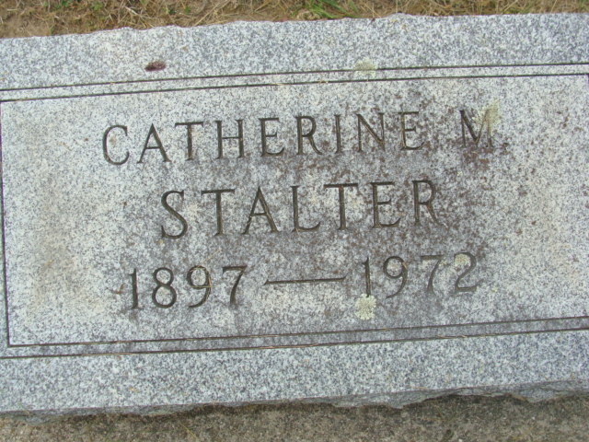
Photo by Alicia Kneuss

CATHERINE STALTER DIES THIS MORNING
Mrs. Catherine M. Stalter, 75, of 148 1/2 South Second Street, and a lifelong resident of Decatur, died at 3:40 a.m. today at the Adams County Memorial Hospital, where she had been a patient for the past three weeks.
She was born in Decatur April 25, 1897, a daughter of Nathan L. and Harriett Butler-Roop, and was married to Dorus A. Stalter Nov. 28, 1914. Her husband preceded her in death Dec. 11, 1971.
Mrs. Stalter was a member of the Women of the Moose, of which she was a past senior regent, the Disabled American Veterans auxiliary, the American Legion auxiliary, the Veterans of Foreign Wars auxiliary, and the Pocahontas Lodge.
Surviving are three sons, Dorus A. Salter (sic) Jr., of Deming, N.M.; Dale W. Stalter of Garrett, and Robert A. Stalter of Tacoma, Wash.; two sisters, Miss Mary Roop of Decatur, and Mrs. Isaac (Chrystal) Wagner of Waterford, Mich.; one brother, Glen Roop of Gibson City, Ill.; seven grandchildren and 11 great-grandchildren. One son, Milo, one sister and three brothers are deceased.
Funeral rites will be conducted at 2:30 p.m. Saturday at the Winteregg-Linn Funeral Home, with Rev. Robert Vander Hart officiating. Burial will be in the Decatur Cemetery. Friends may call at the funeral home after 2 p.m. Friday until time of the services.

Decatur Daily Democrat, Decatur, Adams County, Indiana
Thursday, September 7, 1972

**
RITES ARE SATURDAY FOR MRS. STALTER
Funeral services for Mrs. Catherine M. Stalter, who died Thursday morning, will be held at 2:30 pm Saturday at the Winteregg-Linn Funeral Home, with Rev. Robert Vander Hart officiating. Burial will be in the Decatur Cemetery. Friends may call at the funeral home after 2 pm today until time of the services. The Women of the moose will hold memorial services at 7 pm today at the funeral home.

Unknown source

**
Adams County Indiana Birth Book
Roop _______
Father Nathan
Mother Hattie Butler
Male (sic) White
Born Apr 25 1897
Book H-5 page 24

