Ada Smauthu (Fisher) Stalter
June 22, 1880 – September 2, 1949

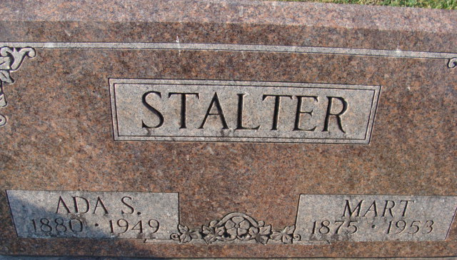
Photo by Alicia Kneuss

Ada Smauthu Stalter
in the Indiana, U.S., Death Certificates, 1899-2017
Name Ada Smauthu Stalter
[Ada Smauthu Fisher]
Gender Female
Race White
Marital Status Married
Age 69
Birth Date 22 Jun 1880
Birth Place Adams County, Indiana
Death Date 2 Sep 1949
Death Place Fort Wayne, Allen, Indiana, USA
Death Registration Date 1949
Father Thomas Fisher
Mother Ruth Mallonee
Informant Mart Stalter; Fort Wayne, Indiana
Burial September 5, 1949; Maplewood Cemetery; Decatur, Indiana

