Nellie Wanda (Daniels) Staley
June 24, 1894 – January 13, 1939

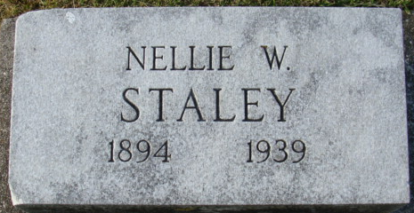
Photo by Alicia Kneuss

DEATH CLAIMS NELLIE STALEY
Mrs. James K. Staley Dies After an Extended Illness
Mrs. Nellie Daniels-Staley, 44, wife of James K. Staley, died last night at her home on North Sixth street, following an extended illness. Death was due to carcinoma. She had been ill for more than two years.
The deceased was born in Preble, June 24, 1894, the daughter of Joseph and Minnie Daniels. She was a registered nurse, a member of the First Christian Church and of the American Legion Axillary here.
Surviving besides the husband, James K., are two children, Marguerite and Roger, both at home; the following brothers and sisters: Mrs. Velma Mann, Rochester, Minnesota; Mrs. Marie Hammond, Decatur; Miss Ruth Daniels, Denver, Colorado; Harold Daniels, Dr. R. E. Daniels and Paul Daniels all of this city and an aunt, Miss Margaret Daniels, also of Decatur.
Funeral services will be held Monday afternoon at 2 o'clock at the home, with the Rev. Kenneth Timmons, pastor of the First Christian Church officiating and burial will be in the Maplewood Cemetery. The body will be returned to the home from the Zwick & Son funeral home tonight at 7 o'clock and may be viewed there until the time of the funeral.

Decatur Daily Democrat, Adams County, Indiana
Saturday, January 14, 1939
**
Indiana, U.S., Death Certificates, 1899-2017
Name Nellia Wanda Staley [Nellia Wanda Daniels]
Gender Female; Race White; Marital Status Married
Age 44
Birth Date 24 Jun 1894; Birth Place Adams County, Indiana
Death Date 13 Jan 1939; Death Place Decatur, Adams, Indiana, USA
Father Joseph H Daniels
Mother Minnie Cross
Spouse James K Staley
Informant Harold Daniels; Decatur, Indiana
Burial January 16, 1939; Decatur Cemetery

