Mary E. (Uhrick) Staley
August 1, 1902 – February 15, 1974

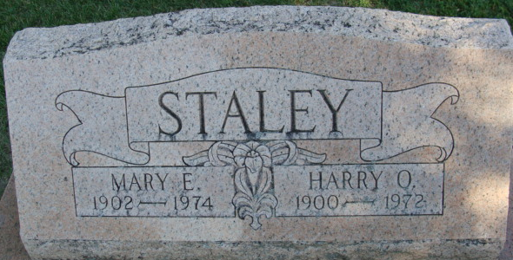
Photo by Alicia Kneuss

Mrs. Mary Staley, 71, of 263 Park Place, widow of Harry O. Staley, died at 1:35 a.m. this morning at the Adams County Memorial Hospital, where she had been hospitalized 10 days.
She was a member of the St. Mark's United Methodist Church. Mr. and Mrs. Staley operated the Staley Confectionery in Decatur from 1934 to 1942.
Born in Adams County on August 1, 1902, she was the daughter of Frank and Rosa Diehl-Uhrick, and was united in marriage on November 16, 1922, to Harry O. Staley, who died April, 1972.
Surviving are three sisters, Mrs. Richard (Emma) Myers of Decatur; Mrs. Roy (Ellen) Klusman of Decatur, and Mrs. Ralph (Clarcie) (sic) Shady of South Whitley; two brothers, Luzerne (Bud) Uhrick of Fort Wayne, and Ernest Uhrick of LaGrange. One brother preceded her in death.
Funeral services will be held at 10:30 a.m. Monday at the Zwick Funeral Home, with Rev. Fuhrman Miller officiating. Burial will be in the Decatur Cemetery. Friends may call at the funeral home after 9 a.m. Sunday until time of the services. The family will be at the funeral home to receive friends from 2 to 4 and 7 to 9 p.m. Sunday.

Decatur Daily Democrat, Adams County, Indiana
Friday, February 15, 1974

