James K. Staley
December 25, 1896 – September 8, 1977

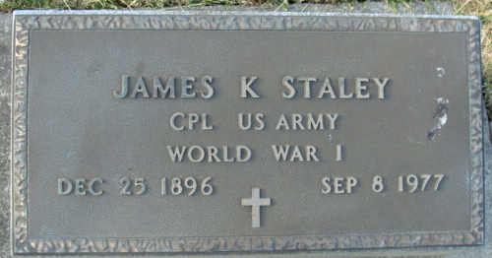
Photo by Alicia Kneuss

Indiana Births, 1880-1920
Name: Staley, ___; Father: Wm; Mother: Emma Miller
County: Jay; Gender: Male; Birth Date: 25 Dec 1896
Reference: Jay County, Indiana Index to Birth Records 1882 - 1920 Inclusive Volume I Letters A - Z Inclusive, Book: H-7, Page: 23
**
James R. Staley
in the U.S., Headstone Applications for Military Veterans, 1861-1985
Name James R. Staley
Rank Corporal
Birth Date 25 Dec 1896
Service Number 1575863
Unit Bett. A.-39th F.a.
Enlistment Date 5 Aug 1917
Discharge Date 15 Jan 1919
Death Date 8 Sep 1977
Cemetery Decatur Cemetery
Cemetery Location Decatur, Indiana, USA

