Harry O. Staley
May 7, 1900 – April 23, 1972

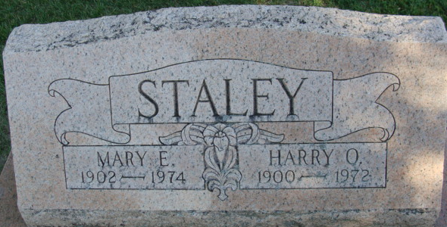
Photo by Alicia Kneuss

Harry O. Staley Taken by Death
Harry O. Staley, 71, former Decatur businessman and retired General Electric Co. employee, died suddenly at 2:45 p.m. Sunday shortly after admittance at the Adams County Memorial Hospital, after being stricken with a heart attack at his home, 263 Park Place.
Mr. Staley owned and operated the Staley Confectionery on South Second Street from 1934 to 1942. He was employed at the General Electric Co. plant here until retiring in 1965.
A son of Joseph and Emma Miller-Staley, he was born at Linn Grove May 7, 1900, and was married to Mary Uhrick Nov. 16, 1922.
Mr. Staley was a member of Masonic Lodge 571, F&AM, and attended St. Mark's United Methodist church.
Surviving are his wife; one sister, Mrs. Forrest (Mable) Murray of Decatur; and one brother, James K. Staley of Decatur.
Funeral services will be conducted at 10:30 a.m. Wednesday at the Zwick Funeral Home, with Rev. William C. Feller officiating. Burial will be in the Decatur Cemetery. Friends may call at the funeral home from 2 to 5 and 7 to 9 p.m. Tuesday.

Decatur Daily Democrat, Adams County, Indiana
Monday, April 24, 1972

