Mervin E. Stahl
August 23, 1914 – March 30, 2002

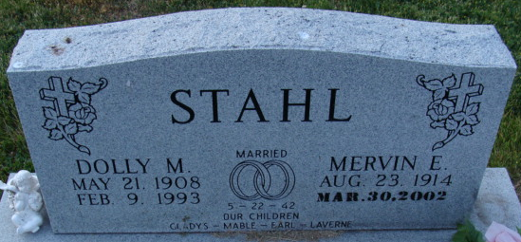
Photo by Alicia Kneuss

Mervin E Stahl
in the Indiana, U.S., Death Certificates, 1899-2017
Name Mervin E Stahl
Gender Male
Race White
Marital Status Widowed
Age 87
Birth Date 23 Aug 1914
Birth Place Indiana
Death Date 30 Mar 2002
Death Place Decatur, Adams, Indiana, USA
Death Registration Date 2002
Father Rufus Stahl
Mother Della Raber
Informant Mr. Tony L. King; gr. [sic]; Decatur, Indiana
Burial April 3, 2002; Decatur Cemetery; Decatur, Indiana

