Dolly M. (Springer) Stahl
May 21, 1908 – February 9, 1993

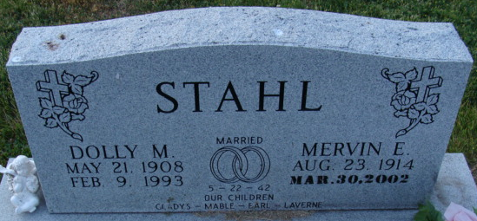
Photo by Alicia Kneuss

Dolly M. Stahl, 84, of Decatur died yesterday in Lakeside Manor.
Surviving is her husband, Mervin; daughter, Mable Freeman of Bluffton; stepson, Earl Stahl of Hartford, Conn.; a sister; a brother; eight grandchild-ren; 28 great grandchildren; and eight great-great-grandchildren.
Services are 2 p.m. tomorrow in Haggard & Armes Funeral Home, Decatur, where calling is 3 to 5 and 7 to 9 p.m. today. Burial will be in Decatur Cemetery.

News-Sentinel, Allen County, Indiana
Wednesday, February 10, 1993

**
Indiana, U.S., Death Certificates, 1899-2017
Name Dolly M Stahl
[Dolly M Springer]
Gender Female
Race White
Marital Status Married
Age 84
Birth Date 21 May 1908
Birth Place Adams County, Indiana
Death Date 9 Feb 1993
Death Place Decatur, Adams, Indiana, USA
Death Registration Date 1993
Father John Springer
Mother Effie [Knavel]
Spouse Mervin Stahl
Informant Mervin Stahl; husband; Decatur, Indiana
Burial February 11, 1993; Decatur Cemetery; Decatur, Indiana

