Cassandra Nicole St. John
May 18, 1994 – May 18, 1994

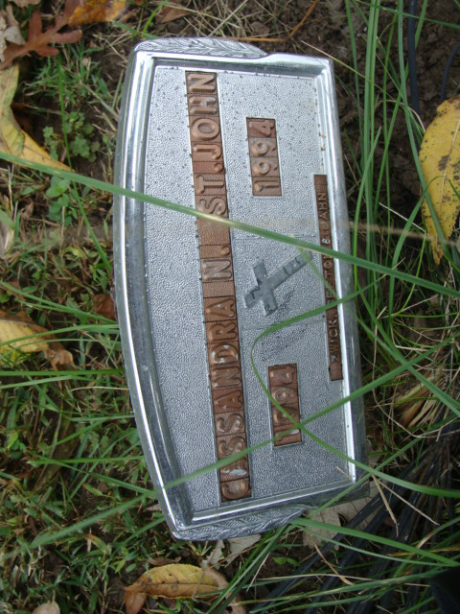
Photo by Alicia Kneuss

Cassandra Nicole St. John of Decatur was stillborn Wednesday in Adams County Memorial Hospital.
Surviving is her mother, Monica J. of Decatur, and brothers, Martin R. and Gabriel U., both at home.
Burial will be in Decatur Cemetery.
Preferred memorials are gifts to the family through Zwick-Sefton & Jahn Funeral Home, Decatur.

News-Sentinel, Allen County, Indiana
Saturday, May 21, 1994

