George H. H. Squier
March 17, 1873 – May 14, 1963

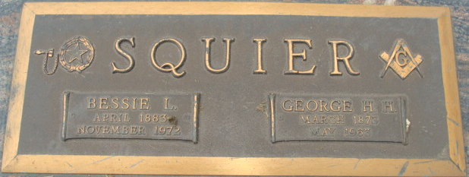
Photo by Alicia Kneuss

George H H Sanier
in the Indiana, U.S., Death Certificates, 1899-2017
Name George H H Squier
Gender Male
Race White
Marital Status Married
Age 90
Birth Date 17 Mar 1873
Birth Place Indiana
Death Date 14 May 1963
Death Place Decatur, Adams, Indiana, USA
Death Registration Date 1963
Father Ellis Squier
Mother Nancy A Logan
Informant Bessie Squier; wife; Decatur, Indiana
Burial May 17, 1963; Decatur Cemetery; Decatur, Indiana

