Bessie L. (Bowers) Squier
April 13, 1883 – November 22, 1972

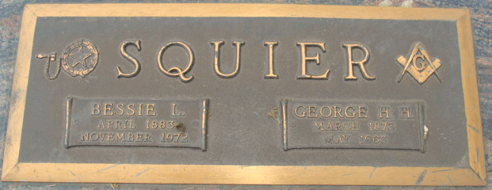
Photo by Alicia Kneuss

Bessie L. Squier Dies at Hospital
Mrs. Bessie L. Squier, 89, of 907 Heaston, Winchester, widow of George H. H. Squier, and a resident of Decatur most of her life, died at 11:30 a.m. Wednesday at the Randolph County Hospital at Winchester, following an extended illness.
Born in Kirkland Township April 13, 1883, she was a daughter of Henry T. and Harriett Mechling-Bowers, and was married to George H. H. Squier Sept. 17, 1910. Her husband preceded her in death May 14, 1963. She had made her home with her daughter in Winchester for the past two years.
Mrs. Squier was a member of the First Christian Church, the Rose Garden Club, and the Adams County Home Demonstration Club. A 50-year member of the Order of Eastern Star, she was a past matron.
Surviving are the daughter, Mrs. Violet Myers of Winchester; a son, Ellis Squier of Santa Monica, Calif.; and one grandchild. Two sisters and two brothers are deceased.
Funeral services will be conducted at 2 p.m. Sunday at the Winteregg-Linn Funeral Home, with Rev. Matthew Worthman officiating. Burial will be in the Decatur Cemetery. Friends may call at the funeral home after 1 p.m. Saturday until time of the services. The Order of Eastern Star will hold services at 7:30 p.m. Saturday.
Decatur Daily Democrat, Adams County, Indiana
Friday, November 24, 1972

