Richard James Spuller
September 13, 1916 – August 15, 1923

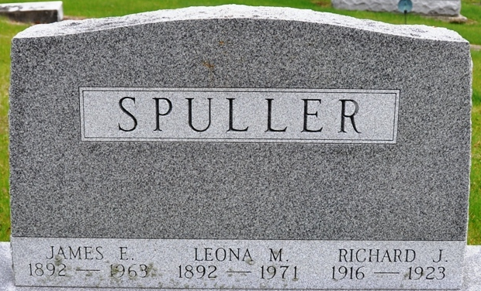
Photo by Deb Curry

SCRATCH FATAL TO SMALL BOY
Blood Poison Results and Richard Spuhler [sic] Dies Early This Morning

Monroe, Ind., Aug. 15-(Special to Daily Democrat)
Richard Spuhler, 7-year-old son of Mr. and Mrs. James Spuhler, of Arcola, Indiana, who with his little sister had been visiting their grandparents, Mr. and Mrs. Jesse Essex, of this city, since last Thursday, died at nine o’clock this morning from blood poisoning, resulting from a small scratch which he received above his eye last Saturday.
The two Spuhler children, together with several other children were playing hide-and-seek at the Essex home last Saturday afternoon. Richard was hunting the other children and, in some manner, ran into a stick which scratched his forehead above his eye. The scratch was not thought to be serious until yesterday, when a doctor was called and declared that blood poisoning had been contracted. The lad was placed immediately under the care of physicians, but the poison had gone through his body too rapidly and he died at nine o’clock this morning.
The funeral of Richard Spuhler will be held tomorrow afternoon at 2 o’clock at the Monroe Methodist Church, and burial will be held at the Decatur Cemetery, it was learned this afternoon.

Decatur Daily Democrat, Adams County, Indiana
Wednesday, August 15, 1923

**
OBITUARY

Richard James, son of James E. and Leona Spuller, was born in Adams County, Indiana, Sept. 13, 1916. The following spring the parents moved to Allen County locating near Arcola, where the boy spent the larger part of his short life.
On Sunday, August 12, the family visited relatives in Monroe and Richard and one of his sisters remained for a week’s stay with his grandparents. On Tuesday night, the boy took suddenly ill and passed away at the home of his grandparents, Mr. and Mrs. J. V. Essex, at 9:15 o’clock, Wednesday morning, aged six years, eleven months and two days.
Thus has the life been cut off in its very bloom. We do not understand why, but it will all be explained in the bye and bye. ‘Till then we wait patiently and give thanks to God that children are included in the atoning Sacrifice of Jesus Christ.
Richard was a well-behaved quiet and bright child. He led his class during his first and only years in school.
He leaves to mourn his untimely departure, his grief-stricken parents, two sisters, one brother, four grandparents, and a large circle of more distant relatives.

Decatur Daily Democrat, Adams County, Indiana
Saturday, August 18, 1923

