Leona (Essex) Spuller
May 1, 1892 – November 4, 1971

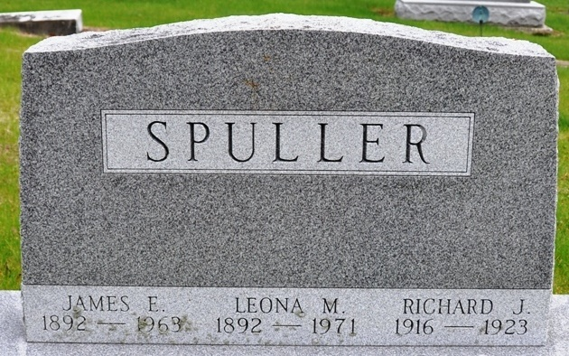
Photo by Deb Curry

Leona Spuller, 79, Dies at Hospital
Mrs. Leona Spuller, 79, of Poe, a native of Monroe, died at 9:45 a.m. Thursday at the Lutheran Hospital in Fort Wayne, where she had been a patient five months. She was born in Monroe and had resided in Allen County 44 years. Mrs. Spuller was a member of the Poe United Methodist Church.
Surviving are two sons, Paul and John Spuller, both of Fort Wayne Route 4; two daughters, Mrs. Dean Smith of Fort Wayne Route 4, and Mrs. Carl Smith of Wolcottville Route 1; two brothers, Harry Essex of Decatur, and Clifford Essex of Monroe; one sister, Mrs. Daniel (Minnie) Kauffman of Decatur Route 6; eight grandchildren and five great-grandchildren.
Funeral rites will be held at 2 p.m. Sunday at the Elzey Home for Funerals, Waynedale, with Rev. O.D. Wissler officiating. Burial will be in the Decatur Cemetery. Friends may call at the funeral home from 7 to 9 p.m. today and 2 to 5 and 7 to 9 p.m. Saturday.
Decatur Daily Democrat; Adams County, Indiana
Friday, November 5, 1971

**
Indiana, U.S., Death Certificates, 1899-2017
Name Leona Spuller
[Leona Essex]
Gender Female
Race White
Age 79
Marital Status Widowed
Birth Date 1 May 1892
Birth Place Indiana
Death Date 4 Nov 1971
Death Place Fort Wayne, Allen, Indiana, USA
Death Registration Date 1971
Father: Jess Essex
Mother: Ann Andrews
Informant: Paul Spuller; son; Fort Wayne, Indiana
Burial: November 7, 1971; Decatur Cemetery; Decatur, Indiana

