James E. Spuller
January 1, 1892 – February 20, 1963

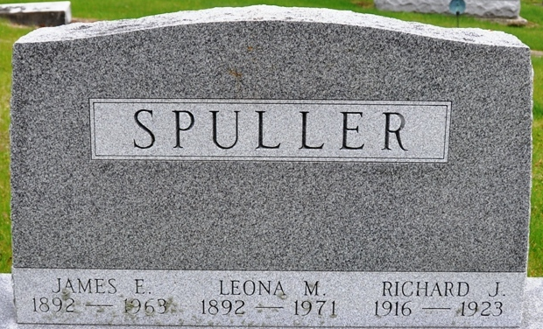
Photo by Deb Curry

James E Spuller
in the Indiana, U.S., Death Certificates, 1899-2017
Name James E Spuller
Gender Male
Race White
Marital Status Married
Age 71
Birth Date 1 Jan 1892
Birth Place Monroe Indiana
Death Date 20 Feb 1963
Death Place Fort Wayne, Allen, Indiana, USA
Death Registration Date 1963
Father Albert Spuller
Mother Ella Grossman
Informant Leona (Essex) Spuller; wife; Fort Wayne, Indiana
Burial February 23, 1963; Decatur Cemetery; Decatur, Indiana

