Aaron Henry Spuller
April 4, 1885 – April 3, 1941

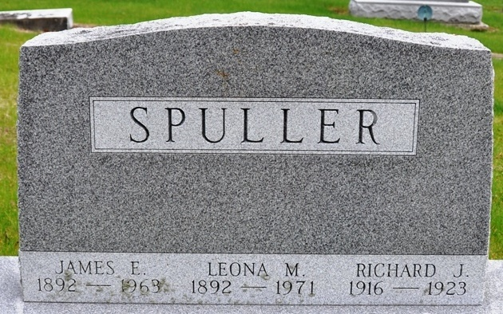
Photo by Deb Curry

Aaron Henry Spuller
in the Michigan, U.S., Death Records, 1867-1952
Name Aaron Henry Spuller
Gender Male
Race White
Marital Status Divorced
Death Age 55
Birth Date 4 Apr 1885
Birth Place Elkhalls Kansas
Death Date 3 Apr 1941
Death Place Detroit, Wayne, Michigan, USA
Father Fred Spuller
Mother Caroline L Gephart
Spouse Latara V. Brown
Informant Mrs. Clara Dague; Decatur, Indiana
Removal April 4, 1941; Decatur, Indiana
File Number 277171

