John Fred Spuhler
July 10, 1844 – January 12, 1920

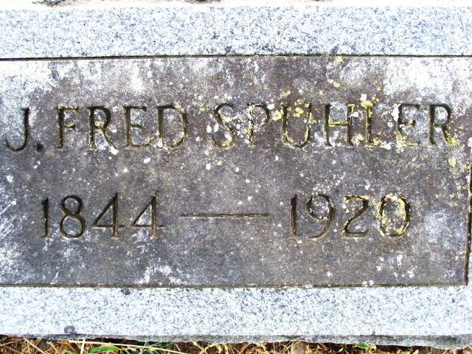
Photo by Alicia Kneuss

Frozen Body of Aged Man Found at Decatur

The remains of John F. Spuhler, 76, frozen stiff, and partly disfigured by rats and mice, was found on the floor of his home at Decatur yesterday by a neighbor. Apparently there had been a fire in the house, and it is believed that he was overcome by the smoke after he had succeeded in extinguishing the flames.

Goshen News, Elkhart County, Indiana
December 13, 1920

**
Indiana, U.S., Death Certificates, 1899-2017
Name J Fred Spuhler
Gender Male
Race White
Age 75
Marital Status Divorced
Birth Date 10 Jul 1844
Birth Place Switzerland
Death Date 12 Jan 1920
Death Place Decatur, Adams, Indiana, USA
Death Registration Date 1920
Parents not listed
Informant: Can't read
Burial: January 13, 1920; Decatur Cemetery

