Vera Mae (Quigley) Sprunger
May 7, 1893 – November 19, 1984

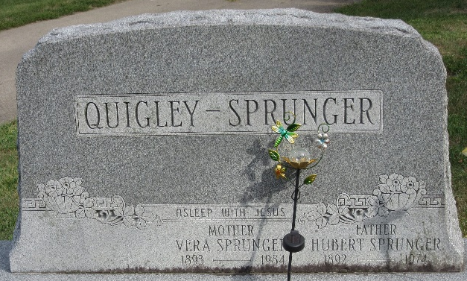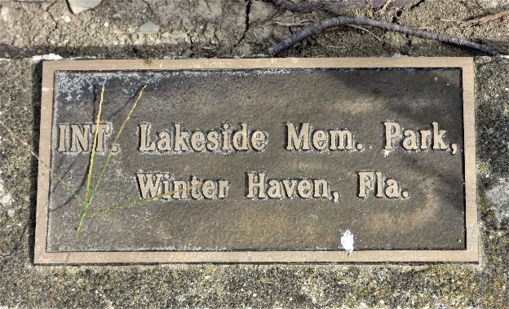
Photo by PLS

Vera Mae Sprunger
in the Florida, U.S., Death Index, 1877-1998
Name Vera Mae Sprunger
Race White
Age at Death 91
Birth Date 7 May 1893
Death Date 19 Nov 1984
Death Place Polk, Florida, United States
**
Indiana, U.S., Marriages, 1810-2001
Name Vera Quigley
Gender Female
Race White
Age 24
Birth Date 7 May 1893; Birth Place Ohio
Marriage Date 2 Jan 1917; Marriage Place Indiana, United States
Residence Place Adams, Indiana
Father Americus Quigley
Mother Mary Brown
Spouse Hubert Sprunger
Officiator Will Hammell
Page 139
FHL Film Number 002321630

