Marilyn J. (Beer) Sprunger
October 6, 1929 – June 26, 2014

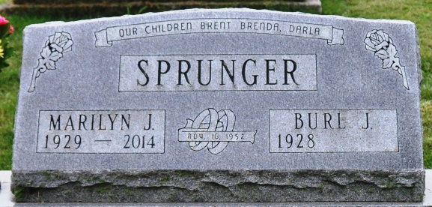
Photo by Deb Curry

Marilyn J. Sprunger, 84, of Decatur, Indiana, died at her residence on Thursday, June 26, 2014. She was born on October 6, 1929 to Leroy and Jennie M. (Frauhiger) Beer in Decatur. On November 16, 1952, she married Burl J. Sprunger.
Marilyn was a lifetime member of Union Chapel United Methodist Church and served as Assistant Sunday School and Bible School teacher. She was employed by Schafer, Wertzbergers & Ehlers Restaurants. She was also secretary to H.R. McClenahan, Suttles Insurance and retired from First State Bank.
She is survived by her husband of 61 years Burl J. Sprunger of Decatur, IN; a son Brent J. (Lori Carpenter) Sprunger of rural Decatur; two daughters Brenda (Mike) Shifferly and Darla J. (Rex) Braun both of Decatur; a brother Wendell (Carol) Beer of Decatur; grandchildren, Lucas (Ashley Myers) Shifferly, Tiffany (Tom) Hoffman, Stephany (Kyle) Kauffman, Alexis (Roger) Pickens, Lindsey Braun (fiancé Adam Brite) and Logan Braun. She was preceded in death by two brothers Leroy Jr. & Rodrick Beer and a sister Joan Harrell.
Visitation will be from Noon-6:00 p.m. Sunday, June 29, 2014, at Haggard-Sefton & Hirschy Funeral Home. Funeral services will be at 11:00 a.m. Monday, June 30, 2014 also at the funeral home with calling 1 hour prior to services. Pastor Jerry Setser officiating, and burial will be in Decatur Cemetery.
Memorials are to Boy's and Girl's Club of Decatur and Union Chapel UMC.

Haggard & Sefton Funeral Home, Adams County, Indiana
June 27, 2014

