Laura D. (Neuenschwander) Sprunger
March 8, 1933 – December 5, 2003

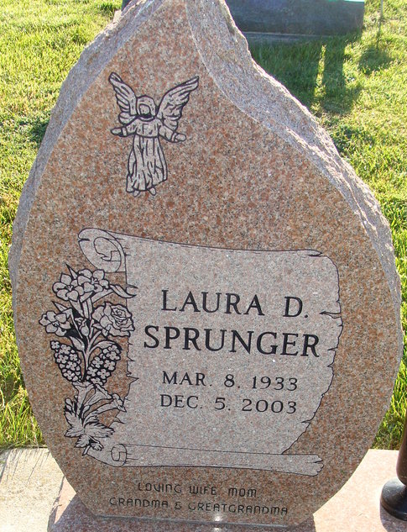
Photo by Alicia Kneuss

Laura D. Sprunger, 70, died Friday, Dec. 5, 2003, at 3:57 a.m.
Service is 10:30 a.m. Monday, Dec. 8, 2003, at Trinity United Methodist Church. Calling is from 2 to 8 p.m. Sunday at Yager-Kirchhofer Funeral Home, Berne, and one hour before service at the church.

Journal Gazette, Allen County, Indiana
Saturday, December 6, 2003
**
Laura D Sprunger
in the Indiana, U.S., Death Certificates, 1899-2017
Name Laura D Sprunger
[Laura D Neuenschwander]
Gender Female
Race White
Marital Status Married
Age 70
Birth Date 8 Mar 1933
Birth Place Adams County
Death Date 5 Dec 2003
Death Place Berne, Adams, Indiana, USA
Death Registration Date 2003
Father David Neuenschwander
Mother Katherine Amstutz
Spouse Omer Sprunger
Informant Omer Sprunger; husband; Berne, Indiana
Burial December 8, 2003; Decatur Cemetery; Decatur, Indiana

