Jethro B. Sprunger
July 21, 1925 – October 21, 2000

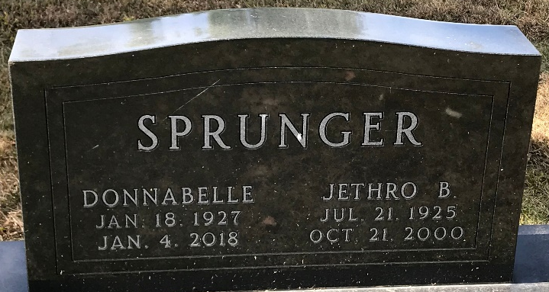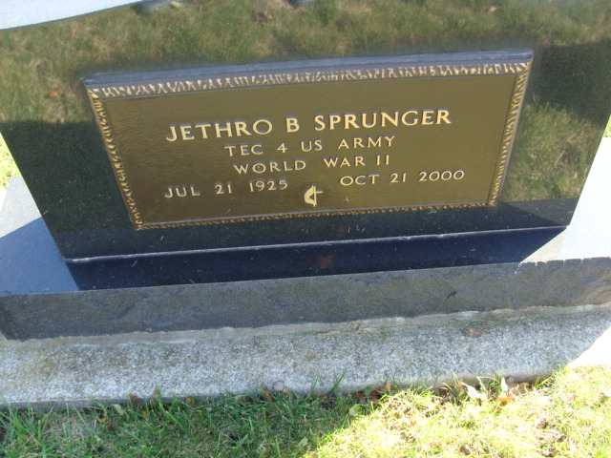
Photo by PLS

Jethro B. Sprunger, age 75, a resident of Decatur, died at 2:10 pm Saturday, Oct 21, 2000, at Adams County Memorial Hospital, Decatur. He was born July 21, 1925 in Berne, to Benjamin Franklin and Nan M. (Eckrote) Sprunger, both deceased. He married Donnabelle Roop on April 4, 1948.
Mr. Sprunger was a member of St. Mark's United Methodist Church and was a furniture restorer. He was employed at Dunbar Furniture for 22 years, then self-employed.
Surviving are two sons, Scot J. Sprunger, Decatur, Jared B. Sprunger, San Diego, California; 2 brothers, Roger Lee Sprunger, Berne and Donald Sprunger, Sweetwater, Tennessee; 2 sisters Gretchen Lehman, Pandora, Ohio and Delores Habegger, Palentine, Illinois and 4 grandchildren.
He was preceded in death by one brother.
Funeral services are 11 a.m. Wednesday, Oct 25, 2000, at Haggard and Sefton Funeral Home, Decatur with Rev. Fuhrman Miller officiating. Burial in Decatur Cemetery, Decatur. Calling hours are Tuesday, October 24, 2000, 2-4 pm and 6-8 pm at Haggard and Sefton Funeral Home, Decatur.
Memorials to St. Mark United Methodist Church.

Decatur Daily Democrat, Adams County, Indiana
Monday, October 23, 2000

