Hubert Sprunger
January 18, 1892 – April 10, 1974

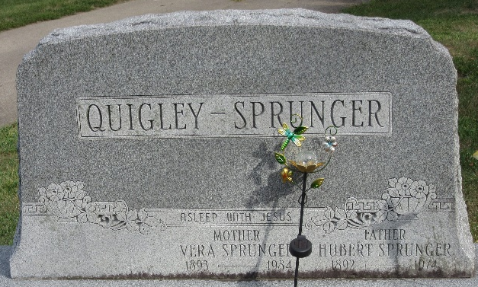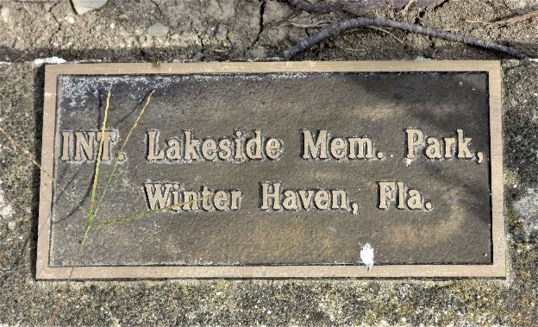
Photo by PLS

Hubert Sprunger Dies in Florida
Hubert Sprunger, 82, a former Adams County resident, died Wednesday at a Winter Haven Fla. hospital, it was learned today.
He was born near Berne on Jan. 18, 1892, the oldest child of Silas and Rosina Riff-Sprunger, and married Vera Mae Quigley on Jan. 3, 1917.
Surviving are his wife, and one daughter, Opal Louise, two brothers, Milo Sprunger, Wawasee Lake, and Fenton Sprunger, Monroe; and one sister, Mrs. Lawrence Von Gunten, Decatur. Two sisters, Mrs. Franklin Van Gunten, and Mrs. A. F. Daily, preceded him in death.
Funeral services will be held at 2 p.m. Saturday at the Crisp funeral home, Winter Haven, with burial at Winter Haven.

Decatur Daily Democrat, Adams County, Indiana
Friday, April 12, 1974

