Geraldine M. (Roughia) Sprunger
May 19, 1924 – June 15, 2016

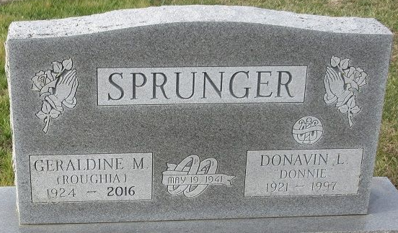
Photo by Deb Curry

Geraldine M. Sprunger, 92 of Decatur, Indiana, passed away on Wednesday, June 15, 2016 at Adams Memorial Hospital. Geraldine was born on May 19, 1924 in Putnam County, Ohio, to the late Glen and Edna (Mullen) Roughia. On May 19, 1941, she married Donavin L. Sprunger; he preceded her in death on November 19, 1997.
She was a member of The First Presbyterian Church in Decatur. She retired from the cafeteria at Bellmont High School and she also worked a homemaker.
Geraldine is survived by a son, Alan (Kathi) Sprunger of Wolcottville, Indiana; 6 grandchildren and 10 great grandchildren. Son-in-law, Harold DeBolt of Van Wert, Ohio.
She was also preceded in death by a daughter, Sharon DeBolt; parents: Glen & Edna Mullen Roughia; 2 brothers, Leonard and Arnold Roughia; 2 sisters, Dorothy Marckel and Pauline Moses.
A Funeral Service will be held at 1:00 p.m. on Monday, June 20, 2016 at Haggard-Sefton & Hirschy Funeral Home, with visitation 2 hours prior to service from 11:00 a.m. - 1:00 p.m. Officiating will be Pastor Laura Sherwood and burial will take place immediately following in the Decatur Cemetery.
Memorials may be made to The First Presbyterian Church.

Haggard & Sefton Funeral Home, Adams County, Indiana
June 16, 2016

