Donavin L. Sprunger
January 17, 1921 – November 19, 1997

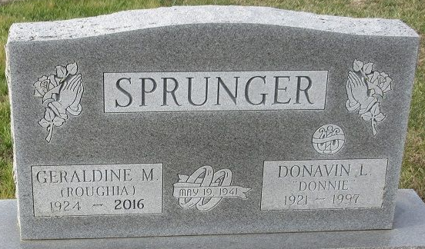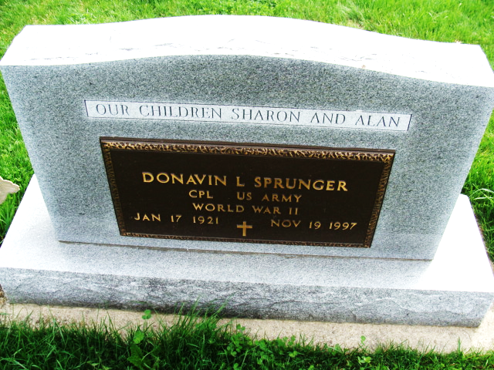
Photo by Deb Curry

Donavin L. Sprunger
in the Indiana, U.S., Death Certificates, 1899-2017
Name Donavin L. Sprunger
Gender Male
Race White
Marital Status Married
Age 76
Birth Date 17 Jan 1921
Birth Place Adams County, Indiana
Death Date 19 Nov 1997
Death Place Fort Wayne, Allen, Indiana, USA
Death Registration Date 1997
Father Herman E. Sprunger
Mother Armanda Hirschy
Spouse Geraldine Roughia
Informant Geraldine Roughia Sprunger; wife; Decatur, Indiana
Burial November 22, 1997; Decatur Cemetery; Decatur, Indiana

