Burl John Sprunger
April 22, 1928 – March 12, 2023

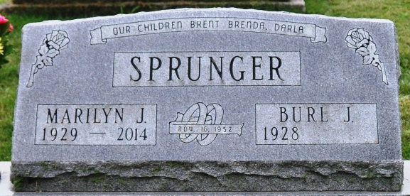
Photo by Deb Curry

Burl Sprunger, 94, of Decatur, IN, passed away peacefully on Sunday, March 12, 2023, at Cedarhurst Memory Care of Fort Wayne, IN. He was born on April 22, 1928, in Berne, IN. Burl married sweet Marilyn J. Beer on November 16, 1952; she preceded him in death on June 26, 2014.
Burl was a hard worker. He worked many years for Paul Strickler at Adams County Trailer Sales. He was a very talented auctioneer for Ed F. Sprunger, Walt Wiegman and Ron Wiegman.
He was self-employed as an excavator and a car dealer. Burl owned the Filling Station in Berne, now that building is currently, The Filling Station Coffee Shop. In recent years, he loved seeing his great grandchildren and driving around in his golf cart.
He is survived by his son, Brent and Lori Sprunger; 2 daughters, Brenda and Mike Shifferly and Darla and Rex Braun; 6 grandchildren, Lucas and Ashley Shifferly, Tiffany and Tom Hoffman, Stephany and Kyle Kauffman, Lexy and Roger Pickens, Lindsey and Adam Brite and Logan Braun; 7 great grandchildren, Griffin and Maverick Kauffman, Grayson, Geyer and Everly Pickens, Mack and Lillie Brite; a sister, Carol Lehman; a sister-in-law, Cleora Sprunger.
Burl was preceded in death by 3 brothers, Bruce and Galen Sprunger, Warren Sprunger, Earl and Marinel Sprunger.
Private family services were held by Haggard-Hirschy & Zelt Funeral Home, followed by burial in Decatur Cemetery. Family will have a Celebration of Life, at a later date.
Memorials are to Boys and Girls Club of Adams County.

Haggard & Sefton Funeral Home, Adams County, Indiana
March 14, 2023
**

Indiana, U.S., Birth Certificates, 1907-1944
Name Burl John Sprunger
Gender Male
Birth Date 22 Apr 1928; Birth Place Monroe, Adams, Indiana, USA
Father Howard Russel Sprunger; age 29
Mother Bertha Helen Long; age 27; 3rd child; all living
Certificate Number 15493
Roll number 40474_357751
Volume Range 31 - 35

