Walter A. Springer
March 19, 1890 – September 4, 1944

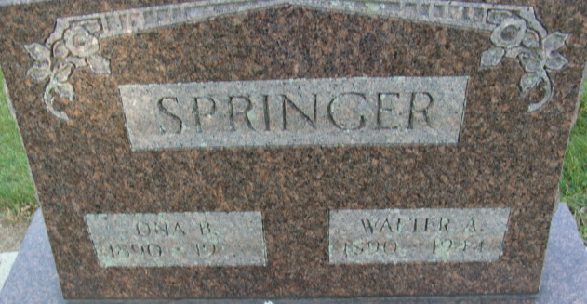
Photo by Alicia Kneuss

Death • Ohio, Deaths, 1908-1953

Name Walter A Springer
Sex Male; Age 54; Race W
Birth Date 19 Mar 1890; Birthplace Adams Co., Indiana
Residence Date 04 Sep 1944; Residence Place Dayton, Montomery, Ohio
Address 1509 Watervliet Ave.
Burial Date 07 Sep 1944; Burial Place Decatur, Ind.
Marital Status Married
Occupation Punch Press Oper.N.C.R.Co
Father's Name Orlando Springer; Father's Birthplace Ohio
Mother's Name Victoria Pring; Mother's Birthplace Ohio
Spouse's Name Ona; age 54
Event Type Death
Event Date 04 Sep 1944
Event Place Dayton, Montgomery, Ohio
Cemetery Maple Wood Cemetery; Decatur, Indiana
Informant Ona Springer
Source Details fn 57604

