Rachel P. Springer
June 13, 1891 – January 3, 1945

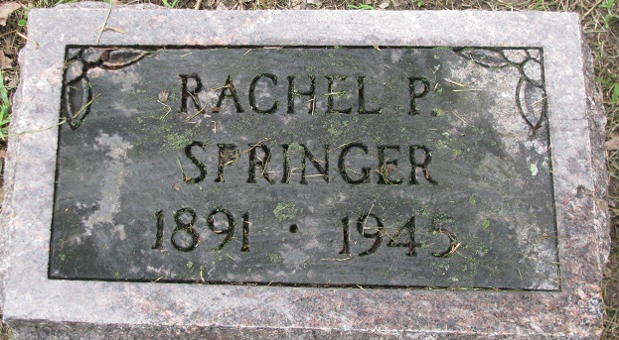
Photo by PLS

Rachel P Springer
in the Indiana, U.S., Death Certificates, 1899-2017
Name Rachel P Springer
Gender Female
Race White
Marital Status Single
Age 53
Birth Date 13 Jun 1891
Birth Place Indiana
Death Date 3 Jan 1945
Death Place County Infirmary, Adams, Indiana, USA
Death Registration Date 1945
Father Orlando Springer
Mother Victoria Renolys
Informant Miss Mabel Springer; Rockford, Ohio
Burial January 7, 1945; Decatur Cemetery; Decatur, Indiana

