Perry Pring Springer
April 19, 1868 – June 25, 1903

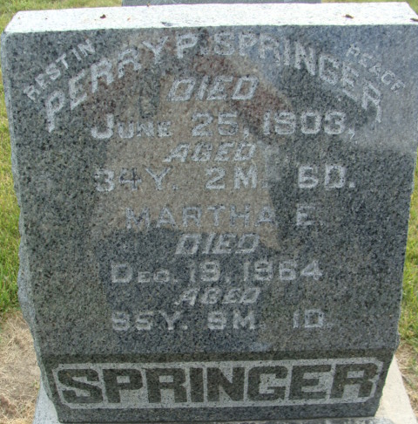
Photo by Alicia Kneuss

DECATUR – Perry Springer, thirty-two, married, was run down by a westbound Chicago & Erie passenger train receiving fatal injuries.

The Indianapolis Star, Marion County, Indiana
Saturday, June 26, 1903
**
Indiana, U.S., Death Certificates, 1899-2017
Name Parry Pring Springer
Gender Male
Race White
Marital Status Married
Age 34
Birth Date 19 Apr 1868
Birth Place Adams A Indiana
Death Date 25 Jun 1903; railroad accident
Death Place Decatur, Adams, Indiana, USA
Death Registration Date 1903
Father Samuel Springer
Mother Pernetta Pring
Spouse Martha Ella
Informant Martha E. Springer; Decatur, Indiana
Burial June 27, 1903; City Cemetery

