Orlando Wellington Springer
February 23, 1866 – October 17, 1937

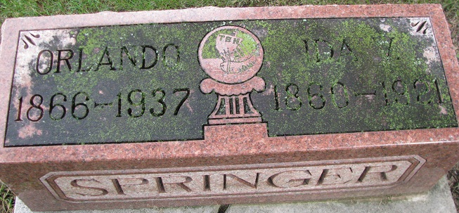
Photo by PLS

Oilano Wellington Springer
in the Indiana, U.S., Death Certificates, 1899-2017
Name Orlano Wellington Springer
Gender Male
Race White
Marital Status Widowed
Age 71 years, 7 months, 22 days
Birth Date 23 Feb. 1866
Birth Place Adams County, Indiana
Death Date 17 Oct 1937
Death Place Decatur, Adams, Indiana, USA
Death Registration Date 1937
Father Samuel Springer
Mother Ida Renalds [sic - wife]
Informant Mrs. Dorwin Drake; Decatur, Indiana
Burial October 21, 1937; Decatur Cemetery

