Ona B. (Cottrell) Springer
May 14, 1890 – June 22, 1957

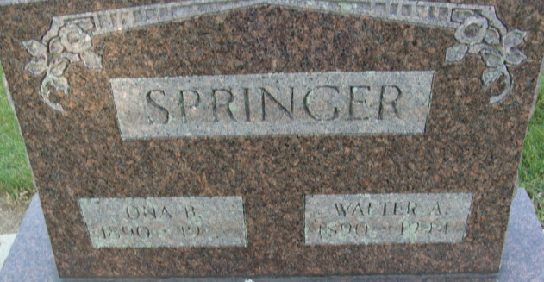
Photo by Alicia Kneuss

MRS. WALTER SPRINGER OF DAYTON, OHIO, DIES

Mrs. One Belle Springer, 67, widow of Walter Springer, Decatur, half-sister of Isaac B. Rash, Columbia City, was found dead Saturday in her home at Dayton, Ohio. She had apparently died Friday, the victim of a heart attack.
The funeral will be at 2 p.m. Tuesday in Decatur at the Black Funeral Home with burial in the Decatur Cemetery.

Unknown source
**
Indiana, U.S., Marriages, 1810-2001
Name Ona Cottrell
Gender Female
Race White
Age 31
Birth Date 14 May 1890
Birth Place Adams, Indiana
Marriage Date 29 Jun 1921
Marriage Place Indiana, United States
Residence Place Decatur, Indiana
Father Berg Cottrell
Mother Emma Bodle
Spouse Walter A Springer
Page 335

**
Ona B Cottrell from tree Brake Family Tree
Birth 14 May 1890 Adams, Indiana, USA
Marriage 29 Jun 1921 Adams, Indiana, USA
Residence 1940 Dayton, Montgomery, Ohio, USA
Death 22 Jun 1957
Father General Burgoyne Cottrell (1848-1901)
Mother Emma Nancy Bodle (1860-1927)
Spouse Walter A Springer (1890-1944)

