Oca P. (Durbin) Springer
March 8, 1891 – July 3, 1941

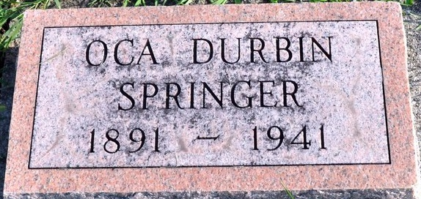
Photo by Deb Curry

DEATH CLAIMS MRS. SPRINGER
Former Adams County Resident Dies Thursday at Fort Wayne
Funeral services will be held Sunday afternoon for Mrs. Grant Springer, 50, former Adams County resident, who died Thursday night at her home in Fort Wayne, following a stroke.
The deceased, formerly Oca Durbin, was born in Monroe on March 8, 1891. She had resided in Fort Wayne for the past 18 years.
Surviving is the husband, a son, Doyle; two daughters, Berniece and Anna Marie; a brother, O. H. Durbin of Watervliet, Michigan and two sisters, Mrs. Henry Cook of Decatur and Mrs. Ora Mitchel, also of this city.
Services will be held at 1:30 o'clock Sunday afternoon at the Mungovan funeral home and the body will be brought here for burial. The casket will be opened at the cemetery.

Decatur Daily Democrat, Adams County, Indiana
Saturday, July 5, 1941

