Martha Ellen (Mallonee) Springer-Teeter
March 18, 1869 – December 19, 1964

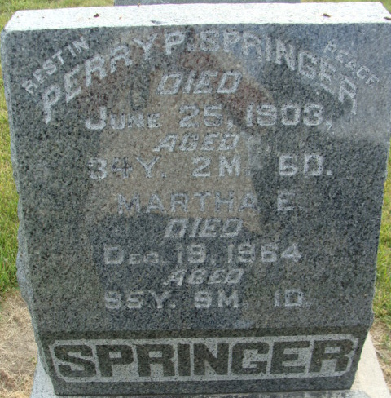
Photo by Alicia Kneuss

Martha Ellen Teeter
in the Indiana, U.S., Death Certificates, 1899-2017
Name Martha Ellen Teeter
[Martha Ellen Mallonee]
Gender Female
Race White
Marital Status Widowed
Age 95
Birth Date 18 Mar 1869
Birth Place Indiana
Death Date 19 Dec 1964
Death Place Berne, Adams, Indiana, USA
Death Registration Date 1964
Father Joseph Mallonee
Mother Susanna Dunifon
Informant Mrs. Alvie Teeter; daughter; Berne, Indiana
Burial December 21, 1964; Decatur Cemetery; Decatur, Indiana

**
Indiana, U.S., Marriage Certificates, 1960-2012
Name Ella Mallonee
Gender Female
Race White
Marriage Age 22
Birth Date 1868
Birth Place Union, Adams, Indiana
Marriage License Date 22 Dec 1890
Marriage Date 24 Dec 1890
Marriage Place Adams, Indiana, USA
Residence Place Union, Adams, Indiana
Spouse Perry Springer
**
Indiana, U.S., Marriages, 1810-2001

Name Martha E Springer
[Martha E Mallence]
Gender Female
Race White
Age 37
Event Type Marriage Registration (Marriage)
Birth Date 18 Mar 1869
Birth Place Adams, Indiana
Marriage Date 22 Nov 1906
Marriage Place Indiana, United States
Residence Place Decatur, Indiana
Father Joseph Mallence
Mother Susanna Duniphan
Spouse John F Teeter
Officiator David Gerber
Page 47
FHL Film Number 002321466

