Marcella M. (Walters) Springer
September 23, 1930 – June 8, 2007

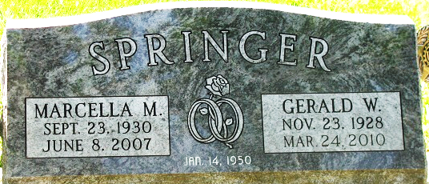
Photo by PLS

Marcella M. Springer, 76 years old of Decatur, Indiana, passed away at 1:15 p.m. on Friday, June 8, 2007 in the Village of Heritage located in Monroeville, Indiana. Marcella was born on September 23, 1930 in Adams County, Indiana, the daughter of the late Forrest S. Walters and the late Xariffa M. (Barkley) Walters. She married Gerald W. Springer on January 14, 1949 in Adams County, Indiana, and he survives.
Marcella was a member of the Union Chapel United Methodist Church in rural Decatur, Indiana, where she was a Sunday School teacher for many years. Marcella was also a member of the Root Township Home Extension Club and enjoyed bowling in the Decatur Bowling Leagues.
Marcella was a homemaker and had worked at Preble Gardens Restaurant from 1983 to 1993.
Surviving are her husband, Gerald W. Springer of Decatur, Indiana, daughter, Linda Emenheiser of Decatur, Indiana, son, Larry Springer of Monroe, Indiana, son, Jeffrey A. Springer of Decatur, Indiana, daughter, Mrs. Victor (Jennifer) Kable of Decatur, Indiana, brother, Leroy Walters of Decatur, Indiana, cousin, Betty Walters of Decatur, Indiana, ten grandchildren, seven great-grandchildren.
Preceding Marcella in death was one grandson, Matthew Springer.
Funeral services will be held at 10:30 a.m. Tuesday, June 12, 2007 in the Zwick & Jahn Funeral Home with the Rev. Ed Karges officiating. Interment will follow in the Decatur Cemetery.
Friends will be received from 2-4 and 5-8 p.m. Monday, June 11, 2007 in the Zwick and Jahn Funeral Home, Decatur Indiana.
Preferred memorials are to the Parkinson Foundation or Parkview Hospice.

Zwick & Jahn Funeral Home, Adams County, Indiana
June 9, 2007

