Mable Mae Springer
April 10, 1894 – April 29, 1961

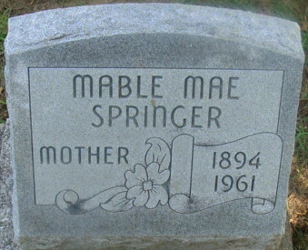
Photo by Alicia Kneuss

Mrs. Mable Springer, 67, Rockford RFD 2, died at 5:30 a.m. today in the Van Wert County Hospital where she had been a patient since Tuesday, following a coronary attack.
She was born April 10, 1894, in Decatur, Ind., the daughter of Orlando and Ida (Reynolds) Springer.
Surviving are a daughter, Mrs. Robert Gephart, Rockford RFD 2, with whom she made her home; three sisters, Mrs. Clarence Chronister of Wren, Mrs. Samuel Cottrell and Mrs. Dorwin Drake, both of Decatur; seven grandchildren; and one great-grandchild.
One brother and one sister preceded her in death.
Funeral services will be held at 2 p.m. Tuesday in the Bobo Methodist Church, Bobo, Ind., of which she was a member, with the Rev. Christian to officiate. Burial will be in the Maplewood Cemetery in Decatur.
Friends may call at the Gephart home on Route 33, three and one-half miles west of Rockford after 7:30 p.m. Sunday. The Ketcham Funeral Home is in charge of arrangement.
Van Wert Times Bulletin; Van Wert County, Ohio
Saturday, April 29, 1961

