Lawrence Z. Springer
March 1, 1902 – March 15, 1992

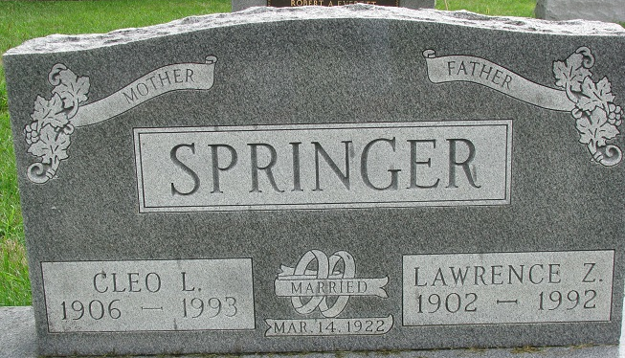
Photo by Alicia Kneuss

Lawrence Z Springer
in the Indiana, U.S., Death Certificates, 1899-2017
Name Lawrence Z Springer
Gender Male
Race White
Marital Status Married
Age 90
Birth Date 1 Mar 1902
Birth Place Adams County, Indiana
Death Date 15 Mar 1992
Death Place Ossian, Wells, Indiana, USA
Death Registration Date 1992
Father David Springer
Mother Amanda A Brandberry
Spouse Cleo L. Debolt
Informant Cleo Springer; wife; Decatur, Indiana
Burial March 17, 1992; Decatur Cemetery; Decatur, Indiana

