John P. Springer
February 2, 1954 -

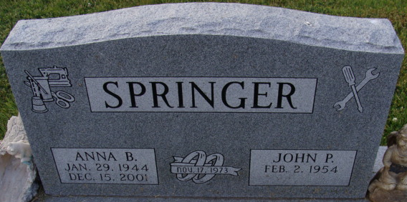
Photo by Alicia Kneuss

