Ida V. (Rennels) Springer
June 4, 1860 – October 2, 1921

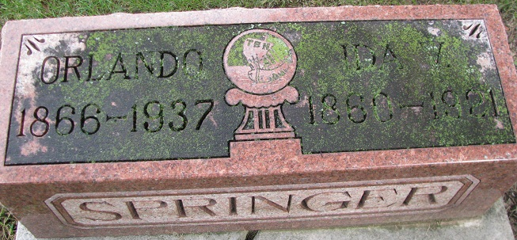
Photo by PLS

Mrs Ida V Springer
in the Indiana, U.S., Death Certificates, 1899-2017
Name Mrs Ida V Springer
[Mrs Ida V Rennels]
Gender Female
Race White
Marital Status Married
Age 61
Birth Date 4 Jun 1860
Birth Place Country Near Sandyville Ohio
Death Date 2 Oct 1921
Death Place Bobo, Adams, Indiana, USA
Death Registration Date 1921
Father Sampson Rennels
Mother Rachel
Spouse Orlando W Springer
Informant Mrs. Henry Colter; Bobo, Indiana
Burial October 4, 1921; Decatur Cemetery

