Gerald W. Springer
November 23, 1928 – March 24, 2010

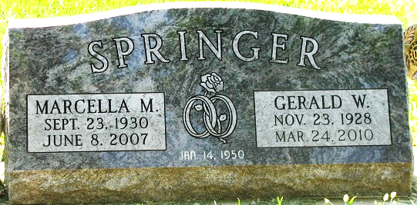
Photo by PLS

Gerald W. Springer, 81 years old of Decatur, Indiana, passed away at 6:00 p.m. on Wednesday, March 24, 2010 in the Village of Heritage located in Monroeville, Indiana.
Gerald was born on Friday, November 23, 1928 in Adams County, Indiana the son of the late Lawrence Springer and the late Cleo (Debolt) Springer. He married Marcella M. Walters on January 14, 1950 in Adams County, Indiana and she passed away on June 8, 2007.
Gerald was a member of the American Legion Post #43 in Decatur, Moose Lodge #1311 in Decatur and the Teamster's Local #114. He enjoyed farming, cutting wood, and gardening. Gerald served his country in the United States Navy from 1945-1947. Gerald retired from E. W. Bohren Transport in Woodburn, Indiana in 1983 as a truck driver and then worked for Prestress as a truck driver for several years following Bohren.
Surviving are his daughter, Linda Emenhiser of Decatur, son, Larry Springer of Monroe, daughter, Jennifer (Victor) Kable of Decatur, sister, Marjorie Conrad of Decatur, sister, Patricia Hackman of North Carolina, ten grandchildren and twelve great-grandchildren. Preceding Gerald in death were one son, Jeffrey Springer and one grandson, Matthew Springer.
Funeral services will be held at 10:30 a.m. Monday, March 29, 2010 in the Zwick & Jahn Funeral Home with Rev. Ernie Suman officiating. Friends will be received from 12:00 NOON - 4:00 p.m. and 5:00 p.m. - 7:00 p.m., Sunday in the Zwick and Jahn Funeral Home, Decatur, Indiana.
Preferred memorials are to A.C.C.F. -Cancer Fund in memory of Jeff Springer.
Zwick & Jahn Funeral Home, Adams County, Indiana
March 24, 2010

