Ervin Springer
July 30, 1900 – May 30, 1955

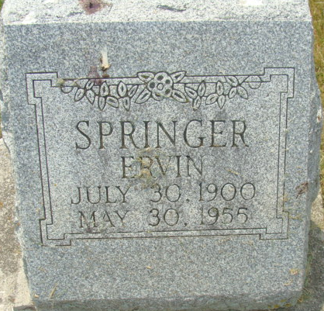
Photo by Alicia Kneuss

Ervin Springer
in the Indiana, U.S., Death Certificates, 1899-2017
Name Ervin Springer
Gender Male
Race White
Marital Status Married
Age 54
Birth Date 30 Jul 1900
Birth Place Allen County, Indiana
Death Date 30 May 1955
Death Place Decatur, Adams, Indiana, USA
Death Registration Date 1955
Father Charles Springer
Mother Mary Lehrman
Informant Mrs. Ervin Springer; Decatur, Indiana
Burial June 2, 1955; Decatur Cemetery; Decatur, Indiana

